Multiple-choice section – choose the correct answer

Question 1 [10.3]

Which pair of events is mutually exclusive?

**A** Rolling a multiple of 3 or a multiple of 2 on a six-sided die.

**B** Drawing a heart or a club from a normal pack of 52 playing cards.

**C** People who like table tennis and people who like badminton.

**D** Students who like History and those who like Geography.

Question 2 [10.4]

The tree diagram below shows the probabilities associated with tossing a biased coin twice.

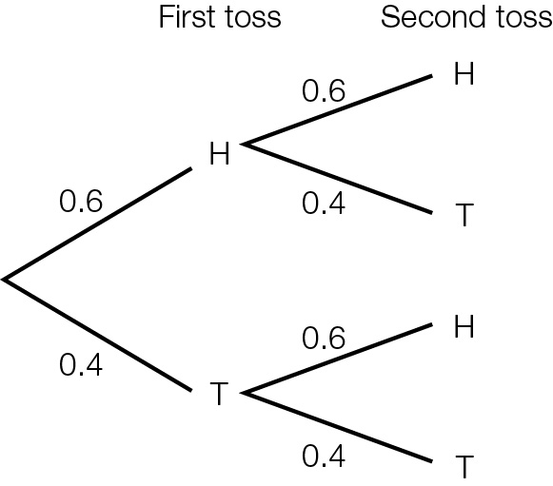

The probability of obtaining tails at least once is:

**A** 0.16 **B** 0.36 **C** 0.48 **D** 0.64

Question 3 [10.5]

A normal die, labelled 1 to 6, is rolled three times. The probability that the third spin results in a 4, given both the previous two spins were both 4, is:

**A**  **B**  **C**  **D** 

Question 4 [10.1]

A lucky dip has 8 movie tickets, 8 music download cards, 10 of both prizes and 4 booby prizes. The probability of randomly choosing movie tickets is:

A  B  C  D 

Question 5 [10.2]

In a group of 10 people, 8 like movie A and 9 like movie B. If all like at least one movie, what is the probability that a person chosen at random likes both movies?

A  B  C  D 

Question 6 [10.5]

I draw 2 cards from a normal pack of 52 playing cards without replacement. What is the probability that the second card is an ace if I know the first card is a not a heart?

**A**  **B**  **C**  **D** 

Question 7 [10.3]

A normal six-sided die is rolled twice. The probability of obtaining a total of two is:

A  B  C  D 

Question 8 [10.4]

A card is drawn from a standard pack of 52. The probability of obtaining a 2 or a club is:

**A**  **B**  **C**  **D** 

Multiple-choice results: ___ / 8

Short answer section

Question 9 2 marks [10.2]

Choose from the following words and expressions to complete the sentences below.

complementary events dependent events independent events sample space tree diagram two-way diagram Venn diagram

(a) Two events that cannot occur at the same time are said to be ____________________________.

(b) A ___________________ consists of a rectangle with one or more circles inside it where the rectangle represents the universal set.

Question 10 1 mark [10.4]

Explain in a sentence what you understand by the phrase ‘a conditional statement’.

Question 11 4 marks [10.2]

Students were surveyed as to which of the sports, basketball and hockey, they had played in the past 2 years. The probability that a person had played basketball only was 0.3, hockey only was 0.4 and both was 0.1.

(a) Complete the following table to show this information.

|  |  |  |  |
| --- | --- | --- | --- |
|  | **basketball** | **not basketball** |  |
| **hockey** |  |  |  |
| **not hockey** |  |  |  |
|  |  |  |  |

(b) Find the probability that a person chosen at random:

(i) had played either sport

(ii) had not played hockey

Question 12 4 marks [10.2]

A total of 15 people participated in a survey to choose their favourite colour.  
8 people chose blue, 6 chose red and 1 person chose neither red nor blue.

**(a)** Draw a Venn diagram to show this information.

**(b)** Find the probability that if a person was chosen at random, they would choose:

**(i)** blue only

**(ii)** red only

**(iii)** both red and blue.

Question 13 5 marks [10.6]

A bag contains 9 Minties and 11 Caramels. Two lollies are selected, one after the other, with no replacement.

**(a)** Draw a tree diagram labelled with probabilities to illustrate this information.

**(b)** Calculate the probability that the lollies are both Minties.

**(c**) Calculate the probability that the lollies are different.

Question 14 5 marks [10.5]

Cards have numbers written on them. There are eight 1s, four 2s, five 3s, two 4s, and four 5s. The cards are well shuffled and one is chosen at random. Find the probability that the card shows:

**(a)** an odd number

**(b)** a prime number

**(c)** a number less than 4, if you know it is odd.

Question 15 4 marks [10.5, 10.6]

Of the 80 members in a karate club, 32 are students and of these, 8 have black belts. There are  
20 members in total with black belts.

(a) Complete the table to show the information.

|  |  |  |  |
| --- | --- | --- | --- |
|  | **Student** | **Not student** |  |
| **Black belt** | 8 |  | 20 |
| **No black belt** |  |  |  |
|  | 32 |  | 80 |

(b) Find the probability that a member chosen at random:

(i) is a student with a black belt

(i) is not a student and does not have a black belt

Question 16 8 marks [10.3]

Cards numbered from 1 to 40 are shuffled then a single card is drawn. Find:

**(a)** Pr(multiple of 3 or 7)

**(b)** Pr(factor of 8 of 20)

**(c)** Pr(odd or a factor of 18)

**(d)** Pr(neither a multiple of 3 nor a multiple of 7)

Question 17 6 marks [10.3]

A normal six-sided die is rolled twice.

(a) Complete the table to show the sample space.

|  |  |  |  |  |  |
| --- | --- | --- | --- | --- | --- |
| (1, 1) | (2, 1) | (3, 1) | (4, 1) | (5, 1) | (6, 1) |
| (1, 2) | (2, 2) | (3, 2) |  |  |  |
| (1, 3) |  |  |  |  |  |
| (1, 4) |  |  |  |  |  |
| (1, 5) |  |  |  |  |  |
| (1, 6) |  |  |  |  |  |

(b) Find the probability of rolling:

**(i)** two numbers that are the same

**(ii)** two numbers that add to give 4

**(iii)** two numbers that add to give 4 or 5

**(iv)** at least one 6.

Question 18 3 marks [10.6]

A couple is trying to decide on names for their new baby. They like the names Amy, Taylor, Rose and Grace. They plan to pick names out of a hat but can’t decide whether to give her one name or two.

(a) How many different outcomes are possible for one name and for two names?

(b) What is the probability that the baby will be named Amy or Amy Rose, if the selection is made randomly from all possible outcomes?

Question 19 4 marks [10.4]

A coin is biased so that the chance of heads is four times that of tails. The coin is tossed three times.

(a) Label this tree diagram with the probabilities along the branches.

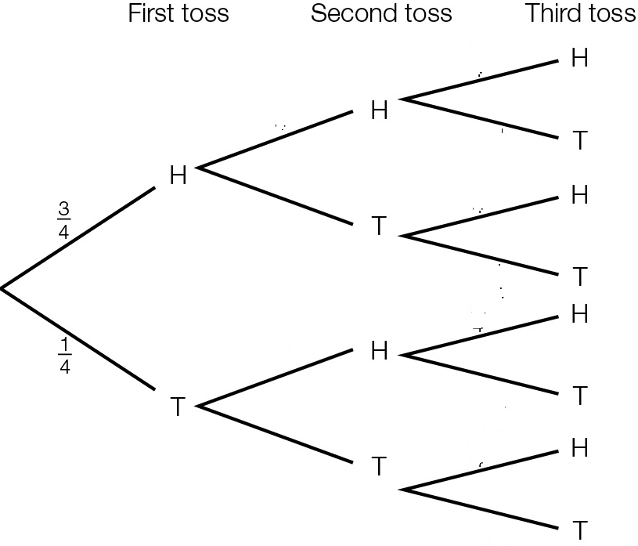

(b) Find the probability of tossing:

(i) three heads in a row

(ii) two tails and one heads in that order

(iii) two tails and one heads in any order.

Question 20 4 marks [10.6]

A bag contains 15 balls, 4 of which are red, 3 are green and the rest blue. A ball is chosen at random, its colour noted and then another ball is chosen without replacing the first ball.

(a)Find the probability that the balls chosen are:

(i) both red

(ii) red then blue, in that order

(iii) red and blue in any order.

(b) Now find the probability that neither ball is blue.

Short answer results: ___ / 50

Extended answer section

Question 21 8 marks [10.2, 10.5]

An organisation employs 60 people. There are 40 people with specialist training in word processing (WP), 32 trained for reception (R), 35 for MYOB, 24 with training in word processing and MYOB, 20 trained for word processing and reception, 18 trained for MYOB and reception and 9 with extra certificates in all three areas. The remainder are involved in administration.

(a) Complete the following Venn diagram to show this information.

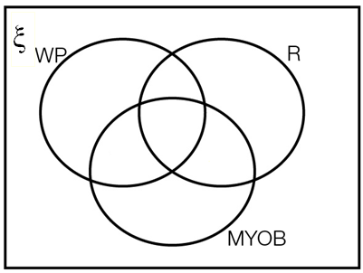

(b) Where on the Venn diagram are the employees involved in administration?

(c) If a person is selected at random, find the probability that the person is involved with:

(i) administration

(ii) at least two of the skills of word processing, MYOB and reception

(iii) no more than one of the skills of word processing, MYOB and reception

(iv) exactly one of the skills of word processing, MYOB and reception.

(d) If a person has MYOB skills, what is the probability they have word processing skills?

Extended answer results: ___ / 8

TOTAL test results: ___ / 66